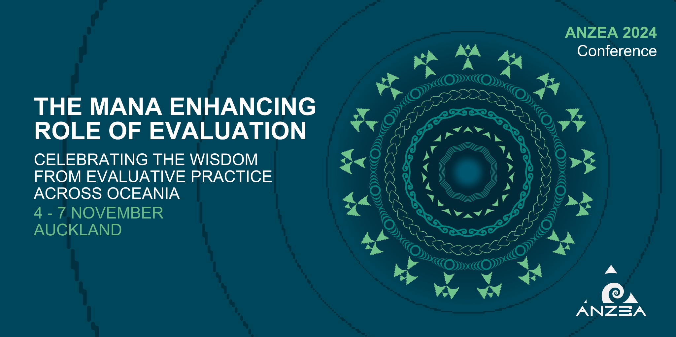

ANZEA 2024 Conference Proposal Submission Form

Key info:
Calls open Monday 4th March 2024 and close Friday 12th April 2024. Notifications will be made in mid-late May.

Proposal formats will include:
- 10 min ignite session
- 20 min short presentation
- 40 min long presentation
- 60 min talanoa or interactive session
- 90 min talanoa or interactive session

Questions or need some help?
Please contact the conference committee at conference@anzea.org.nz and we'll try and assist as best we can!

Connecting your presentations to the theme - what to think about
Because of the diversity we see across our region, and to connect presentations to a talanoa process of sharing and connecting, we want to ensure our call is open and embracing of cultural or holistic concepts that might relate both to the presentation and the conference theme.

Our logo represents the tanoa – the traditional bowl and ceremony – within which the kava is mixed and shared, creating a space for free flowing discussion. This reflects three ideas and areas that are relevant to our work and profession:
- The tanoa - the traditional roots of our work and how they are still used today in your work, in ways that are still mana enhancing. This might be traditional western or indigenous approach and tools that remain as relevant today as they did for our ancestors.
- The kava – the mixing together of ideas, approaches old and new, creating new ‘recipes’ that meet the changing needs of our people, places, and profession.
- The talanoa – the sharing and testing of ideas, creating networks, connections, and ripples that are being sent out and will guide our future ways of working.

The background pattern design – consider the patterns in terms of how they intersect at times and how they diverge at other points. The differing layers of straight and curved patterns speaks to the idea of diversity and the need to, at times, come together (e.g. Western and traditional models used together or merging together) and at other times where they need to stand alone (e.g. the need to use appropriate indigenous models, frameworks that work for the particular participants, communities, funders etc) to support evaluative work.

When preparing your proposal submission, we ask you to reflect on the theme in one or all of these ways and consider how it might connect to them.

You and your mana
To connect with our theme and ambition to show how traditional ways of knowing, being, and doing can be connected to contemporary approaches - we invite you to reflect on proverbs or sayings that are meaningful to you. Alternatively, you may look for inspiration in the traditional knowledge captured in Api and Regina’s book as we did in developing our conference theme.

Provide these either at the beginning or at the end of your proposal and highlight how these guide you and your work in your presentation. Proverb/saying can either be in English or in the indigenous languages they are from. This is not a required field when submitting your proposal.

Contributor contact details
Please submit your proposal to contribute to the ANZEA conference 2024 below.

If you have any questions or issues please contact conference@anzea.org.nz

1. Lead contributor: contact details
This might be different from the main contact person.

Name
Organisation
Address
Address 2
City/Town
Region
Postal Code
Country
Email Address
Contact Number

2. Confirming the main contact person
- Yes, the lead contributor will be treated as the main contact person for your submission
- I would like someone else to be the main contact person. Please include their contact details below

Main contact person (name and email address)

3. Additional contributors (if applicable)
Please enter names and email addresses for each additional contributor.

Proposal details

4. Title of contribution

5. Proposal type
- Ignite session (10 mins)
- Short presentation (20 mins)
- Long presentation (40 mins)
- 60 min talanoa or interactive session
- 90 min talanoa or interactive session
- Other creative or innovative sessions (please specify)

6. Connecting to your mana
If you have reflected upon a proverb or saying in developing your proposal, please include it here with a brief outline of its meaning and connection to your proposal below. These can either be in English or in the indigenous language in which they originate.

7. Contribution outline/abstract (max 300 words)
Please outline your proposal (this is the equivalent to an abstract). It should be clear, concise, informative and set out what your contribution will cover.

8. Connection to our theme and logo
Which aspect(s) of our logo and theme does your proposal connect most strongly to? You're welcome to select more than one. For each that you select please provide a brief explanation. This will help the committee to organise the schedule in a meaningful way.
- The Tanoa - the traditional roots of our work and how they are still used today in your work, in ways that are still mana enhancing. This might be traditional western or indigenous approaches and tools that remain as relevant today as they did for our ancestors.
- The kava – the mixing together of ideas, approaches old and new, creating new ‘recipes’ that meet the changing needs of our people, places, and profession.
- The talanoa – the sharing and testing of ideas, creating networks, connections, and ripples that are being sent out and will guide our future ways of working.
- The pattern - the idea of diversity and the need to, at times, come together and at other times to stand alone to support evaluative work.

9. Please provide some brief notes explaining the rationale for your selections above.
Specifically, how are you hoping your proposal (and the format you’ve selected) will stimulate thinking and/or discussion in relation to the aspect of our theme and/or logo you’ve chosen.

10. Equipment needed
Standard equipment available: Laptop, data projector, whiteboard, flipchart, pens and Blutac.
If you require extra equipment please indicate here.

Thank you for your contribution
Contribution leaders will be informed about their proposal by late May 2022.
Thank you for your proposed contribution.

You may submit more than one proposal.

If you have any questions, please email your question to conference@anzea.org.nz.

